**Strategies Tutorial**

**Note:** This exercise uses PlasmoDB.org as an example, but the same functionality is available on a VEuPathDB resources.

**Learning objectives:**

* Build a multistep strategy
* Use the Text, GO Term, RNA-Seq, and SNP searches
* Combine search results using Boolean operators and the colocation tool
* Transform genes of one organism into their orthologs in another organism
* Infer expression timing from a well-studied organism onto another organism that lacks data.

In this tutorial you will find genes expressed in gametocytes that are likely proteases and have variation in their upstream regions, possibly affecting promoter regions and other gene features. The strategy you build will combine three different searches that query *P. falciparum* data, then transform the *P. falciparum* genes returned by those searches into their *P. vivax* orthologs and look for SNPs in the upstream regions of the *P. vivax­* genes. The ortholog transform enables you make inferences about genes in *P. vivax*, an organism with limited functional data, based on existing data in the closely related and well-studied *P. falciparum*. The *P. vivax* genes returned by the search are likely to share two biological properties, proteolytic activity and expression in gametocytes, and show variation in their upstream regions, possibly affecting promoter regions or other gene features.

**Strategies Overview:**

The strategy system offers over 100 structured searches that can be combined to produce multi-step strategies. Each search queries a specific data set and **returns a list of IDs** that share the biological characteristic defined by the data.

Searches are accessible from the ‘Search For…’ menu on the home page and from the ‘Searches’ dropdown menu in the header of every page. Searches listed under Genes will return a list of gene IDs, while searches listed under ‘SNPs’ or ‘Metabolic Pathways’ will return record IDs representing SNPs, or metabolic pathways.

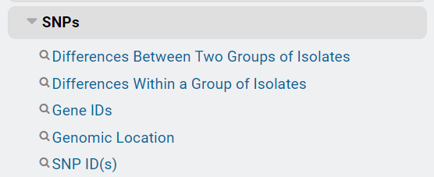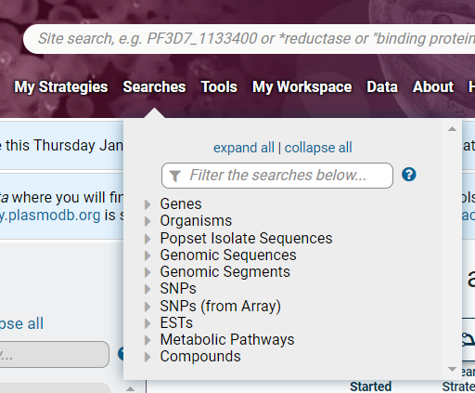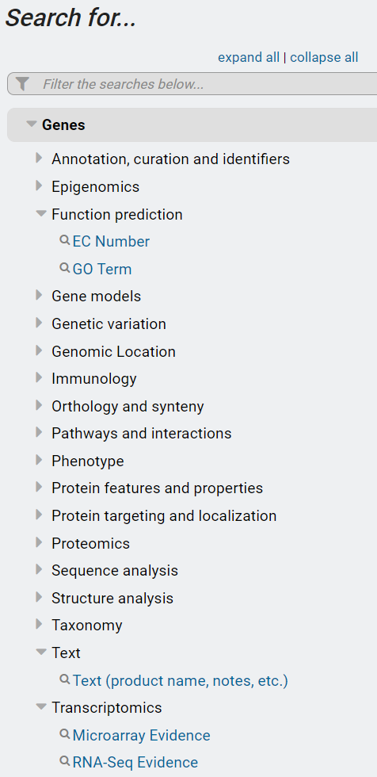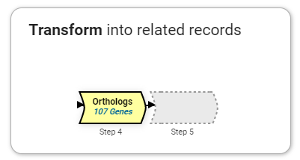

**1**

**2**

**3**

**4**

**5**

The 5 searches you will use in this tutorial are:

1. Identify Genes by Text (product name, notes, etc.) – The search compares your term against the text in the fields that you specify, returning the IDs of gene records that have a match.
2. Identify Genes by GO Term – Returns genes that have your specified Gene Ontology (GO) Term(s) or ID(s) assigned to them.
3. Identify Genes based on RNA Seq Evidence – PlasmoDB integrates raw RNA sequencing data from many different experiments and analyzes all data according to the same workflow to produce expression values. This search returns genes based on their transcript expression as measure by RNA sequencing.
4. Transform by Orthology – PlasmoDB integrates ortholog profiles from OrthoMCL. The OrthoMCL algorithm clusters proteins into ortholog groups based on BLAST similarity across at 150 genomes that span the tree of life. The transform we perform here will convert a list of genes in one organism to their orthologs in a different organism. In this case, we will transform a list of *P. falciparum* genes into their *P. vivax* orthologs.
5. Identify SNPs based on Differences within a Group of Isolates – PlasmoDB integrates whole genome resequencing of isolates and analyzes each isolate for single nucleotide polymorphisms compared to a reference genome. This search returns SNPs that are shared between all the *P. vivax* isolates that are integrated in PlasmoDB.

**Before we get started… a few words about combining search results:**

Each search returns a list of IDs. When two searches are combined, the two result sets (list of IDs) are merged. The table shows the 5 options for combining search results.

|  |  |  |
| --- | --- | --- |
| Operator | : | Combined Result will contain: |
| Screen Clipping | : | IDs in common between the two lists |
| Screen Clipping | : | IDs from list 1 and list 2 |
| Screen Clipping | : | IDs unique to 1 |
| Screen Clipping**……………………………………….** | : | IDs unique to 2 |
| Screen Clipping | : | IDs whose features are near each other (collocated) in the genome |

If the searches return the same type of genomic feature they can be combined using any of the 5 operators (i.e. search 1 returns genes, search 2 returns genes as in screenshot group A below).

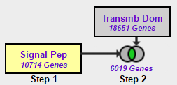

**A**

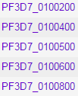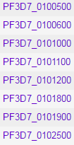

Signal Peptide list

Transmembrane list

**B**

However, searches that return different genomic features will yield no results when combined with intersect, union or minus operators. This is illustrated in screenshot groupings C and D below. Because genes and SNPs are different genomic features, there are no IDs in the list of genes (Step 1) that are present in the list of SNPs (Step 2). To combine a search that returns genes with a search that returns SNPs, you must use the collocation option (1 relative to 2). We know the genomic location of each gene and each SNP and the colocation option is designed to return features based on their relative genomic location, i.e. SNPs that are near or within genes.

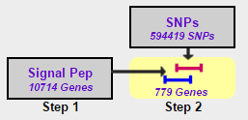

**C**

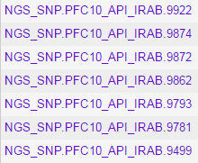

SNPs from Step 2 list

No IDs in common between the lists

**D**

Genes from Step 1 list

**Build the Strategy:**

**Find *P. vivax* genes that are possible proteases, likely expressed during the gametocyte stages and contain SNPs in their upstream regions.** This search strategy employs 4 searches, an ortholog transform and the colocation tool to integrate SNP information. Steps 1 and 2 return *P. falciparum* proteases using two different lines of evidence – a text search in step 1 and a Gene Ontology (GO) term search in step 2. These searches are combined with a union to obtain a more comprehensive list of possible proteases. Step 3 returns genes with evidence for expression during the gametocyte stages based on RNA sequencing data collected in *P. falciparum*. Steps 2 and 3 are combined using the intersect operator to produce a list of genes that have BOTH biological properties: these genes are likely proteases with evidence for expression during gametocyte stages. In the next step, the *P. falciparum* genes returned in the step 3 result are transformed into their *P. vivax* orthologs. This results in a set of 125 *P. vivax* genes with suspected protease activity and expression in gametocytes based on annotation and experimental evidence from *P. falciparum*, an organism for which more complete annotation and functional genomics data is available. In Step 5 we look for single nucleotide polymorphisms (SNPs) among isolates of *P. vivax* and collocate these SNPs to the upstream regions of the *P. vivax* genes. The final result is a set of 32 *P. vivax* genes that are likely proteases expressed in the gametocyte stage and that have SNPs in their upstream regions. Your strategy should look like this when you are done:

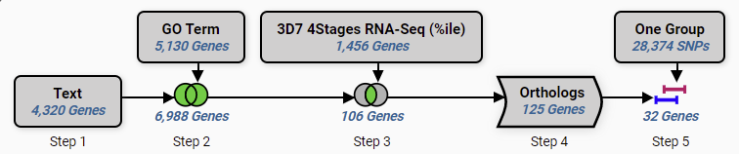­

**Step by Step Instructions**

1. **Run a text search using protease as the text term.**

Identify Genes by Text (product name, notes, etc.): Using the Text Search, find genes whose records contain the term ‘protease’. To reach the text search, click on the link in the home page ‘Search For…’ menu. The page opens showing a list of parameters that are needed to query the data. Every search is loaded with default parameters so that you can click Get Answer and run the search. Change the Text term to ‘protease’ and click Get Answer to initiate the search. The search results are displayed in the My Strategies section which consists of a strategy panel followed by a filter table and a result table.

**Navigation:** >PlasmoDB >Search for Genes >Text > Text (product name, notes, etc.)

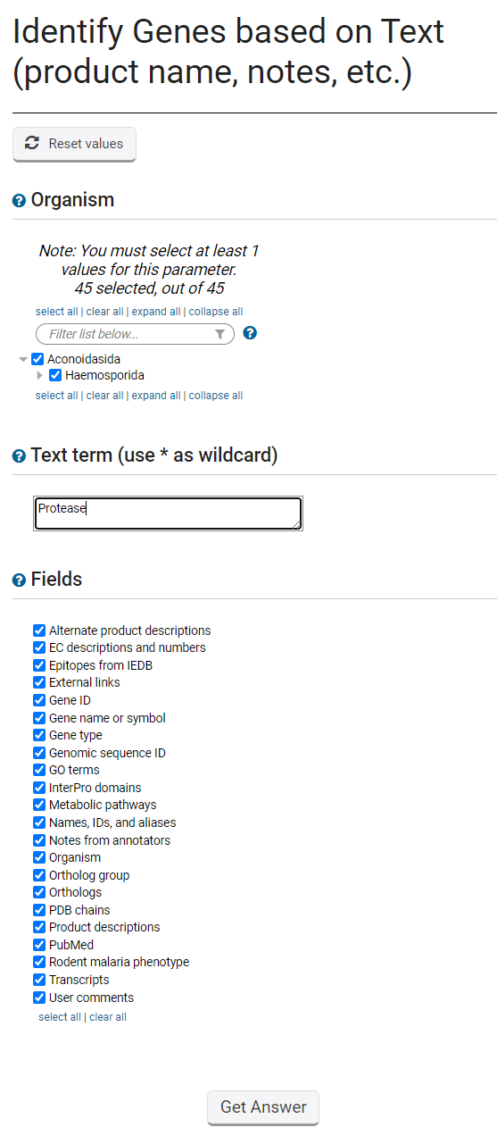

Enter protease

Leave all fields checked. We will use the default setting here.

Click Get Answer to initiate the search

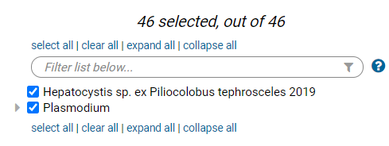

Choose all organisms

|  |  |  |
| --- | --- | --- |
| **Organism** | **:** | Default - all |
| **Text term (use * as wildcard)** | **:** | protease |
| **Fields** | **:** | Default - all |

**Parameters:**

**Results and strategy:** You created a one-step strategy by running the text search. The strategy returns 4320 genes that are annotated with the word ‘protease’. This annotation could appear in any field that you searched. You can analyze this result by exploring the hits. Look at the data in the columns of the result table. You can add more data with the Add Columns button. Clicking a gene ID in the first column will take you to that gene’s record page. Please explore your results to see if they make sense. For example, gene product names might contain the word ‘protease’. Functional data assigned to the genes (GO terms and EC numbers) may indicate protease activity.

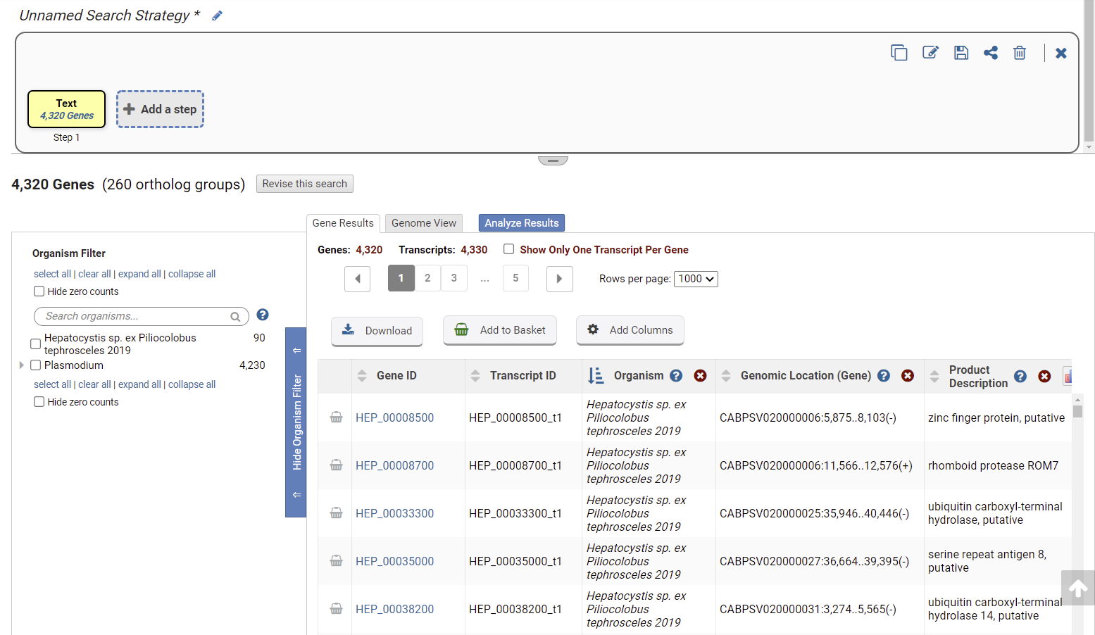

Strategy Box showing your one-step strategy

Result List showing all hits from the search

Filter table showing the distribution of hits across the organisms we searched. Click a # to show only that species

**Add a step choosing to run a search for genes annotated with the biological process gene ontology term – GO:0006508: proteolysis.** Gene Ontology annotations offer a second line of evidence for finding proteases. The ontologies are a controlled vocabulary for describing the molecular function, biological process and subcellular location of a gene product. GO annotations in PlasmoDB were either provided by the sequencing and annotation centers or inferred based on a gene’s similarity to protein domains from the [InterPro](http://www.ebi.ac.uk/interpro/) databases. The GO Term search returns a gene if it is annotated with the GO term that you are looking for. Let’s use that search to look for genes annotated with GO:0006508: proteolysis. We will union the text search results with our GO term results when we combine the results of the two searches.

**Navigation:** Add Step >Combine with other Genes >1 union 2 > A new search >GO Term

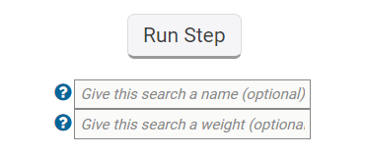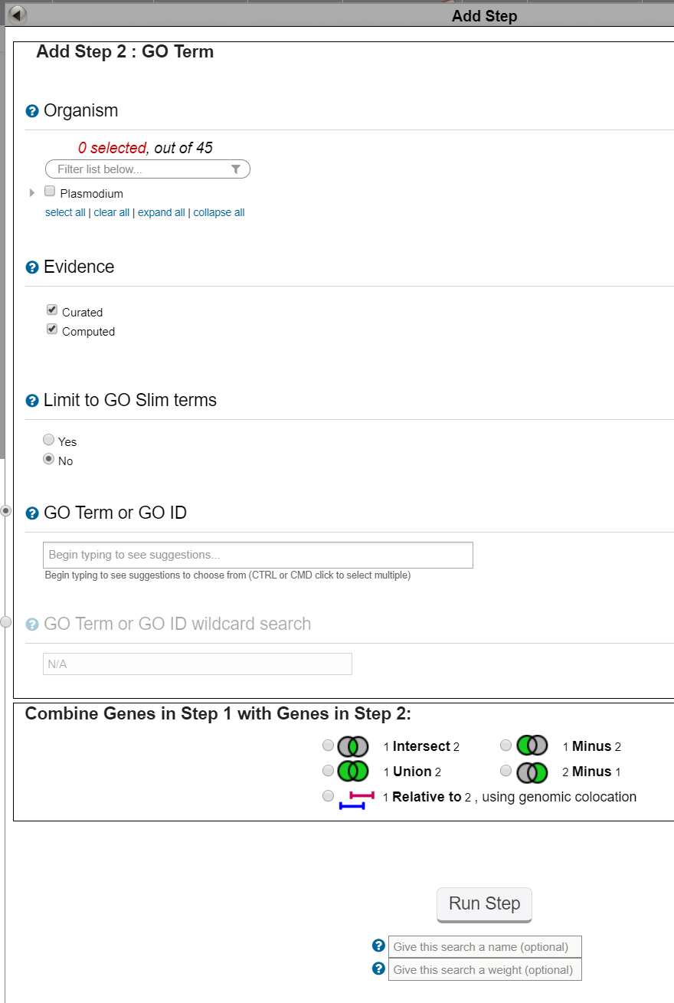

Begin typing Proteolysis and then choose the correct GO term from the list

Which organism is chosen by default for this search? Click ‘select all’ to run the search on all organisms

Click Run Step to initiate the search

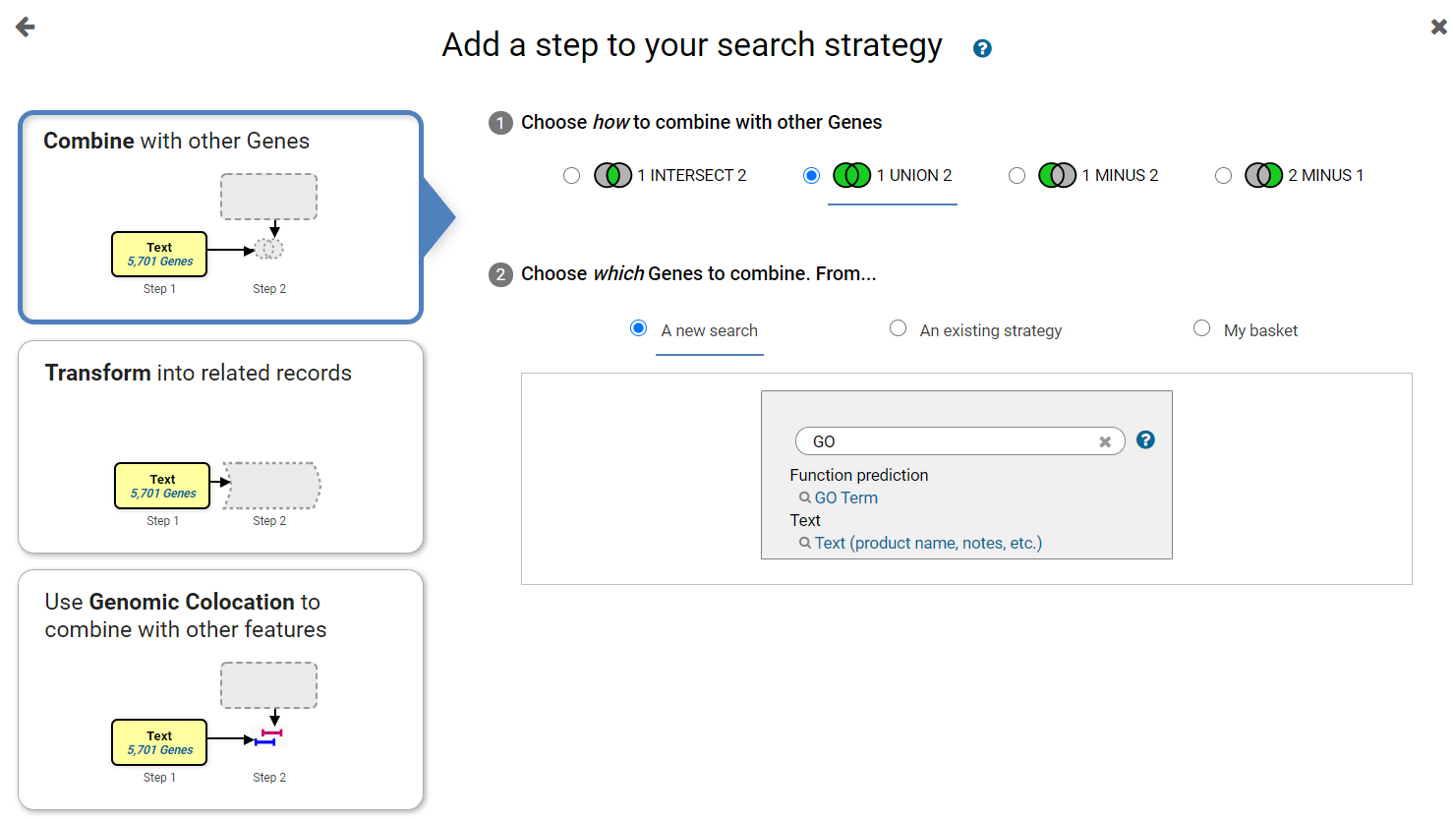

Search for and choose the GO Term search.

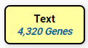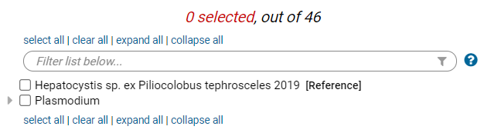

|  |  |  |
| --- | --- | --- |
| **Organism** | : | Choose All |
| **Evidence** | : | Default |
| **Limit to GO Slim Terms?** |  | Default |
| **GO Term or GO ID** | : | GO:0006508 : proteolysis |
| **Free Text (use '*' for wildcard)** | : | N/A |

**Parameters:**

**Combine:**

**Strategy Result:** The GO term search returned 5,235 genes annotated with the proteolysis GO term. The union of the text and GO search returns 7,048 genes that are suspected to have proteolytic activity.

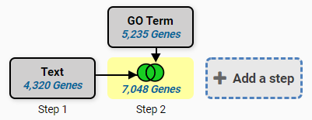

1. **Add a step choosing to run a search for genes based on Transcript Expression using RNA-Seq Evidence.** Since PlasmoDB has integrated several RNA sequencing data sets you must first choose what data set (experiment) to search before you are taken to the search form to choose parameters. Use the Filter Data set tool to choose the Percentile search (P) for ‘Strand specific Transcriptomes of 4 life cycle stages (Lopez-Barragan et al)’. This data set contains the RNA sequencing analysis of two gametocyte samples. Running the percentile search using the default parameters will return the genes whose expression levels are in the top 20% for those samples.

**Navigation**: Add Step >Combine with other Genes >2 intersect 3 >A new search >RNA Seq Evidence

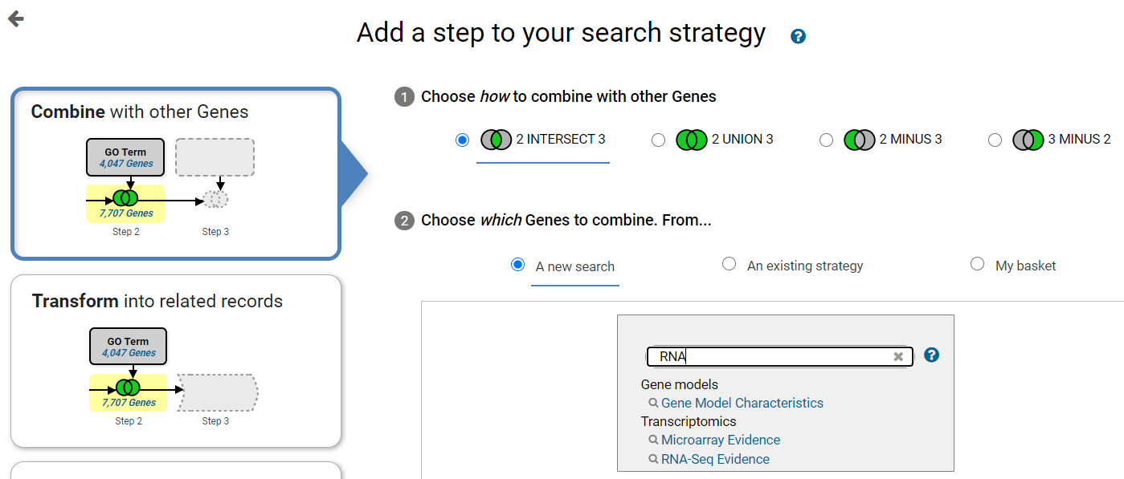

Search for and choose RNA-Seq evidence.

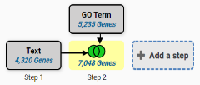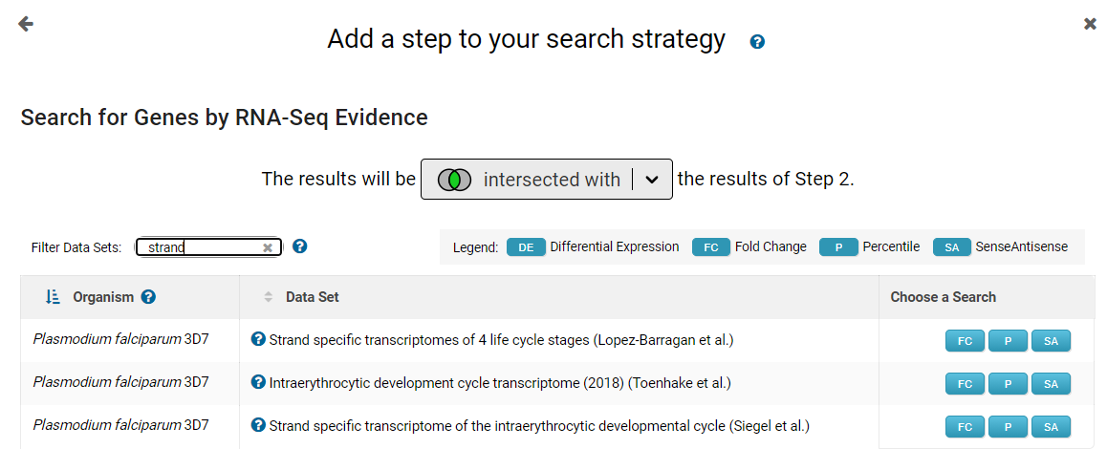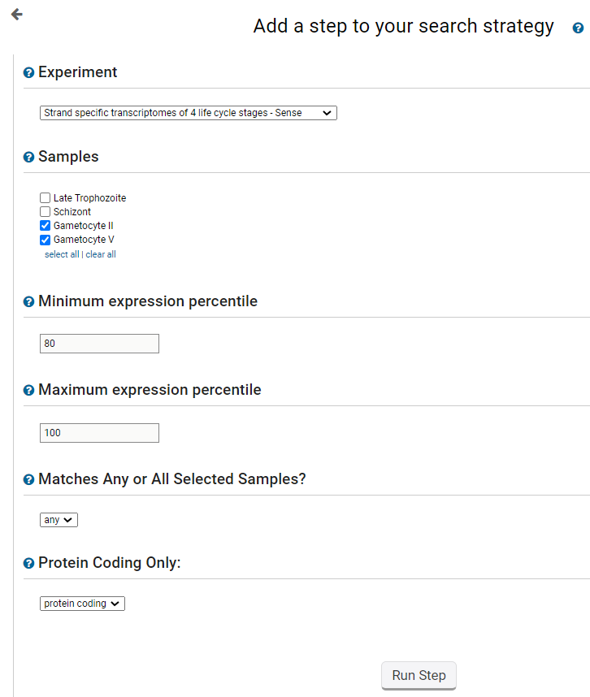

**Parameters:**

|  |  |  |
| --- | --- | --- |
| **Experiment** | : | Strand specific transcriptomes of 4 life cycle stages sense strand |
| **Samples** | : | Gametocyte II, Gametocyte V |
| **Minimum expression percentile** | : | default |
| **Maximum expression percentile** | : | default |
| **Matches Any or All Selected Samples?** | : | default |
| **Protein Coding Only:** | : | default |

**Combine:** Intersecting this search with the previous result will produce a list of genes that are common to both result lists.

**Strategy result:** We have a three-step strategy that returns 106 *P. falciparum* genes that are suspected proteases with evidence for expression in gametocytes based on RNA Sequencing data. Explore your gene list!!

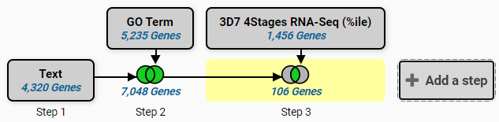

1. **Add a step to the strategy that transforms the 106 *P. falciparum* genes into *P. vivax* genes.**

*P. falciparum* is a well-studied organism with active curatorial efforts and large amounts of functional data. For example, PlasmoDB has 18 RNA sequencing and 11 microarray data sets integrated for *P. falciparum*, but only 4 RNA-Seq and 2 microarray for *P. vivax*. A researcher interested in *P. vivax* can take advantage of the *P. falciparum* data by creating a strategy based on *P. falciparum* data to retrieve genes with the biological properties they are interested in, and then transforming the results to their *P. vivax* orthologs.

**Navigation:** >Add Step >Transform into related records >Orthologs

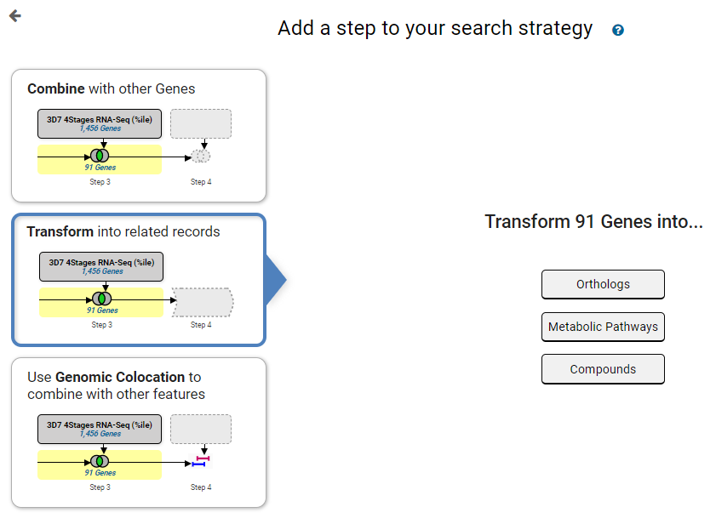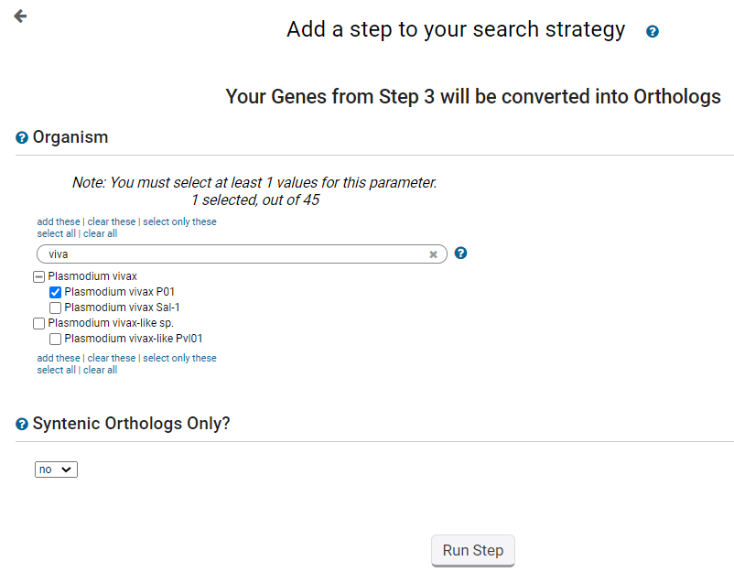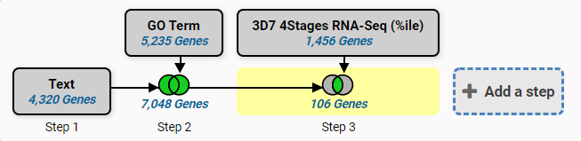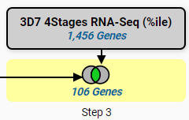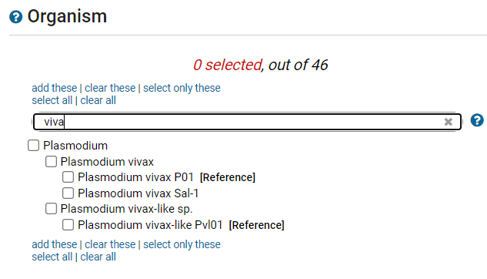

**Parameters:** Choose only *P. vivax* P01 in the Organism parameter of the Add Step Popup.

**Combine:** The ortholog transform function does not combine lists, but instead transforms the results into orthologs from a different species.

**Strategy Result:** We have a four-step strategy that returns 125 *P. vivax* genes that are suspected proteases expressed in gametocytes based on *P. falciparum* RNA Sequencing data.

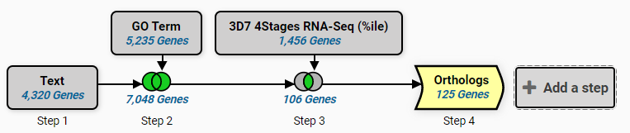

1. **Add a step to the strategy that returns *P vivax* SNPs and collocate those SNPs to the upstream 1000bp of the *P. vivax* genes in step 4.** We can look for variation (SNPs) associated with the genes from Step 4. PlasmoDB integrates whole genome resequencing data from many isolates, and PlasmoDB contains 195 data sets from whole-genome sequencing of *P. vivax* isolates. PlasmoDB analyzes the whole genome sequencing reads by aligning them to the reference genome and then examines the genome one base at a time to find bases in the isolate that do not match the reference sequence. The SNPs are loaded in the database along with other information such as how many sequencing reads supported the SNP call and the genomic location of the SNP. The search we will use analyzes whole genome resequencing data from all *P. vivax* isolates to find SNPs shared between all isolates. You will notice that initiating the search does not immediately bring up the result, but instead leads you to the colocation tool.

**Navigation**: >Add Step >Use Genomic Colocation >A new search >Differences Within a Group of Isolates

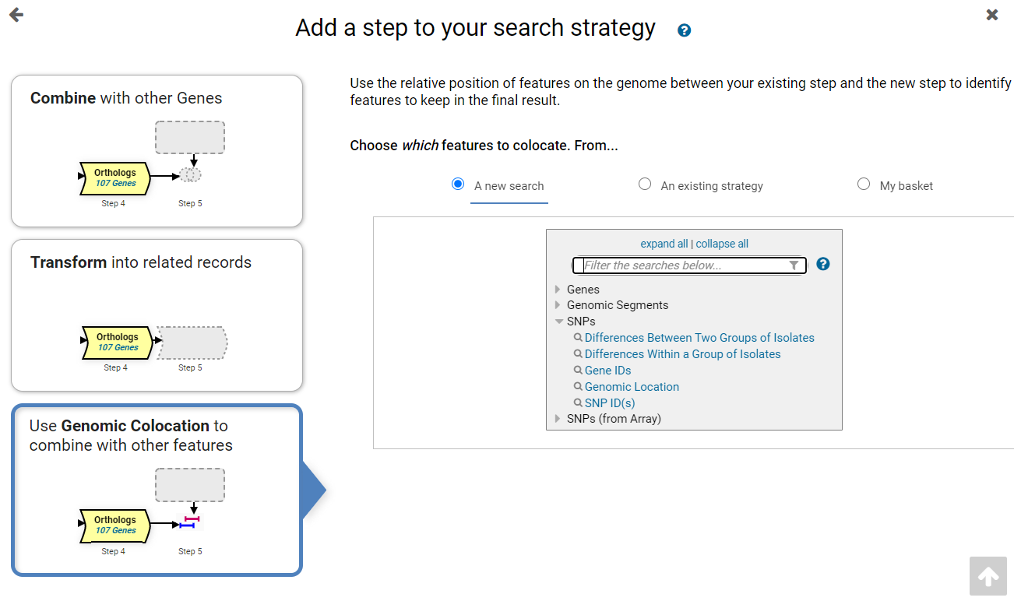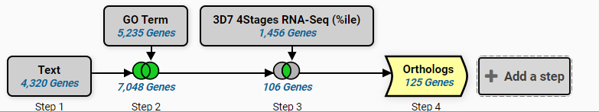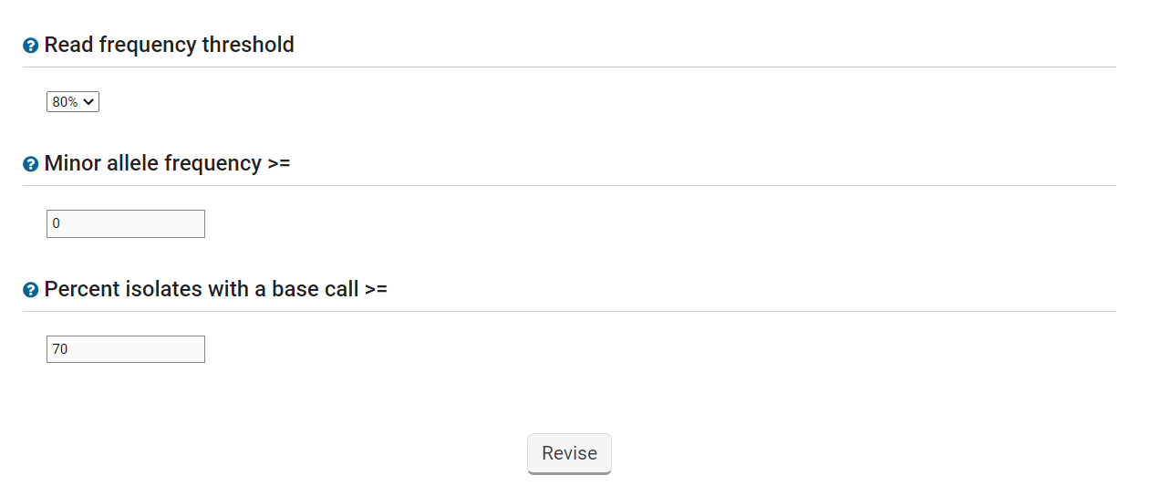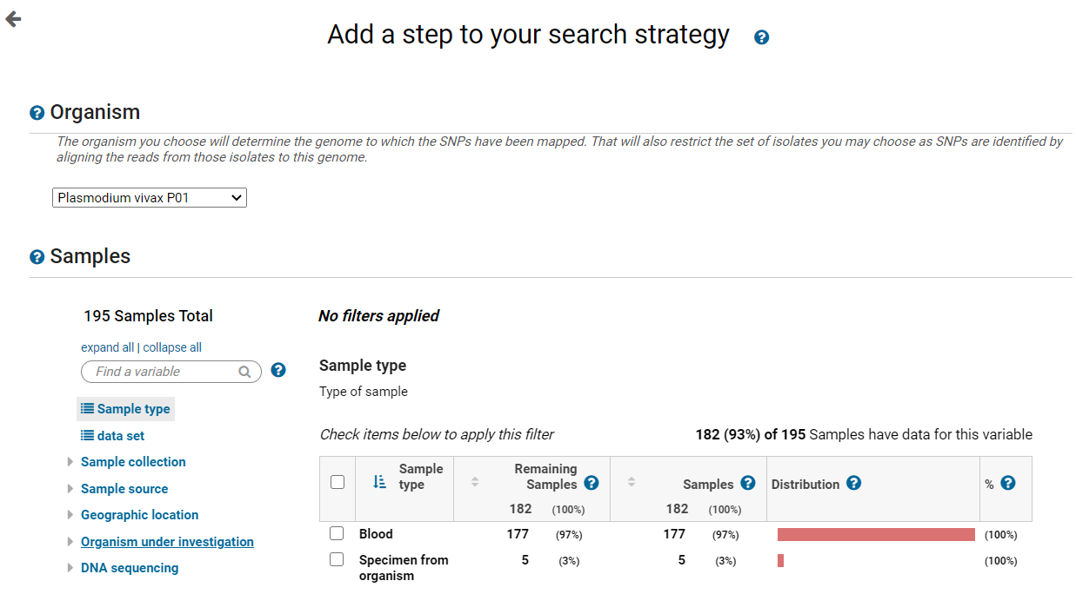

Choose *Plasmodium vivax* P01

Use all 195 isolates (Do not filter)

Percent isolates with base call = 70

|  |  |  |
| --- | --- | --- |
| **Organism** | : | *P. vivax* P01 |
| **Isolates** | : | Default = All Isolates (195) |
| **Read frequency threshold** | : | Default - 80% |
| **Minor allele frequency >=** | : | Default - 0 |
| **Percent isolates with a base call >=** | : | Default - 70 |

**Parameters:**

**Colocation:** Because this search returns SNPs and not genes, the only option for combining the two result lists is by relative genomic location. Arrange the statement in the Colocation popup to read: **Return each Gene from step 4 whose upstream 1000bp region overlaps the exact region of a SNP in Step 5 and is on either strand**. Remember to indicate that you want to locate the SNPs in the upstream region of the gene.

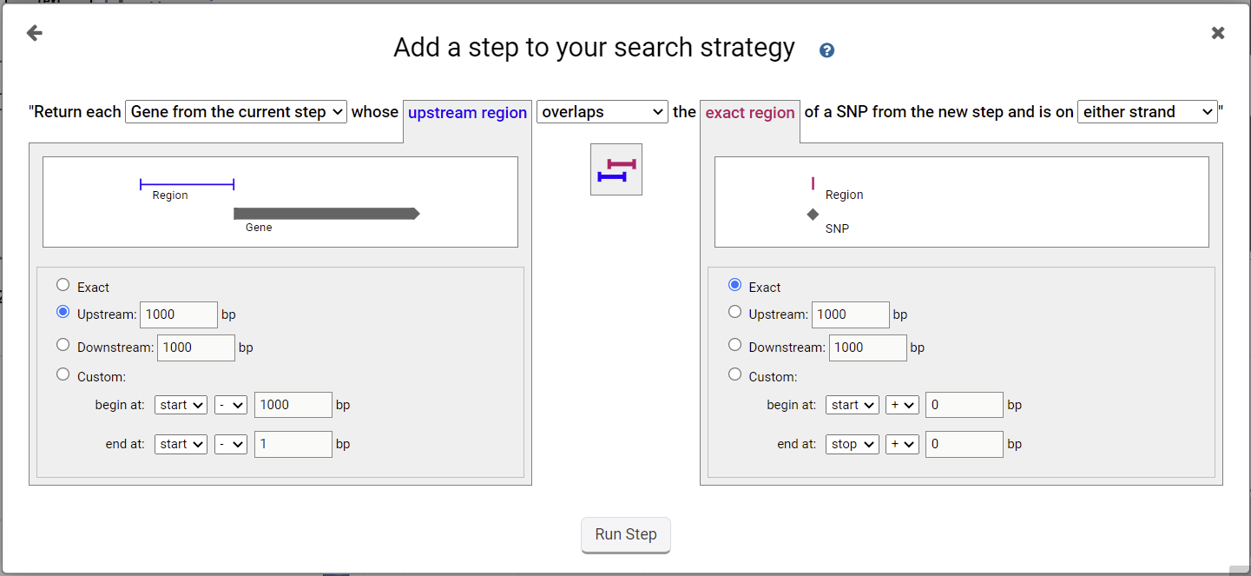

**Strategy: Congratulations!** You have completed the strategy and have a list of 32 *P. vivax* genes that are possible proteases, are likely expressed in gametocytes and have upstream SNPs.

This link will retrieve the completed strategy: <https://plasmodb.org/plasmo/app/workspace/strategies/import/76a3cff6f01535ea>

